# 

**Spring 2023 Newsletter**

Coming up on the heels of pandemic-induced restrictions, 2022 has been a challenging year for the Global economy with de-globalization of trade and investment flows, resurgent inflation and soaring interest rates, food and energy crises linked to the Russian invasion of Ukraine,….Recession is looming on the horizon for many markets. Infrastructure, though credited with being more resilient to cyclical variations, has also been affected in ways that could hardly have been predicted a year ago. And yet, more than ever, investors and fund managers hold the keys to a sustainable recovery and development of our economies and societies. Institutional investors have recognized this by significantly ramping up their commitments, as fund raising by specialist infra funds reached record levels: 195 b$ for unlisted infrastructure in the 2022 - vs 143b in 2021, even though the pace is now slowing down abruptly in 2023 YTD. Simultaneously, we see a trend towards greater specialization strategies, with energy transition and digital infrastructure leading the way, and the emergence of new concerns such as increasing the resilience to cater for Climate-change Adaptation.

And, as we’re going through a rapid shift towards higher interest rates, we can find comfort in the fact that inflation’s positive impact is greater on asset values than the negative impact of rising discount rates for core infrastructure- as argued by our member Arjun in its blog on our website: <http://www.ltiia.org/blog/core-infrastructure-through-its-first-cycle/>

LTIIA will continue to address and explore these trends, old and new, in its quest to promote infrastructure as an asset class through the development of analytical tools and performance benchmarks, as well as through the sharing of best practices among the investment community. As part of its activity program for 2023, it has embarked on the following working themes:

- **Energy transition and Impact on Institutional Investors asset allocation**; How can/do investors manage corresponding risks & bring concrete improvements in energy transition, energy efficiency, energy security? The corresponding working group will hold its last session early June after already half a dozen such meetings that allowed us to identify new trends and fascinating case studies contributed by our members highlighting and showcasing those trends and their impact. The report is expected to be published and disseminated by fall 2023.

Speaking of Energy Transition, we know it will imply moving from a carbon-based economy to a metal-based one, and a corresponding shift from relying on fossil fuels to minerals, in particular rare or “critical” minerals such as Lithium, Cobalt or Nickel necessary to enable the ongoing energy transition and to ensure economic sovereignty within this shift. As it happens another of our members: Infravia just got selected by the French government to manage a newly set up fund to  a dedicated long-term fund - endowed with an initial amount of 1/2b€ to invest in critical metals that support the energy transition and secure supply chains for French and European industries.

- **Biodiversity and Infrastructure**: this new working group was officially launched in mid-May, at the request and with the support of Rivage Investment (an Infra debt fund and LTIIA member) at an event held in Paris with Carbone 4 chair and Founder JM Jancovici . This initiative seeks to bring together representatives from the financial sector, academics, and infrastructure project developers to develop robust methodologies to assess biodiversity impacts of infrastructure assets, as well as operational and regulatory issues related to biodiversity impact management objectives for infrastructure investors .

The objective is resolutely operational: it is about developing an*evaluation method*based on an initial assessment of the state of the art in terms of biodiversity footprint measurement, combining a deconsolidated (by asset class ) and consolidated (global biodiversity footprint expressed in a single indicator.

The ambition is to produce a Proof of concept by autumn 2023, and ultimately, to  evolve towards an Open Source system, so as to maximize its dissemination and impact.

While those 2 themes are be conducted through internal working groups set up this spring, a side-study linked to the Climate-change theme, to be conducted with EDHEC Infra, will revolve around **“Achieving better portfolio diversification with infrastructure equity and debt”.** The aim is to conduct an independent study, backed by robust data, on how investors can achieve diversification within their infrastructure allocation and to show the merits of adding unlisted/ illiquid infrastructure equity and debt to a multi-asset class portfolio. The paper will cover Diversification of the infrastructure portfolio itself and implications for portfolio construction and deal selection, as well as Diversification of the total portfolio with infrastructure investments.This study follows up on the 2022 report jointly commissioned by LTIIA and EDHEC Infra on **Infrastructure resilience to external shocks**, a timely and relevant study disseminated and presented to hundreds of investors & managers globally.

We also plan to link up with newly established research-focused industry bodies, such as IRIS- Investment Researchers in Investment Society.

As part of our on-going collaboration with public organizations, and in-keeping with our role as a bridge between private and public long term investors in infrastructure, we will also engage with our membership  into  the upcoming   consultations envisioned by  OECD such as the **Survey on climate resilient infrastructure** or the **comparative use of Green & Social Bonds use by  Public and Private institutional investors.**

We will also come back to you in the coming weeks with proposals to engage -along with like-minded partner organizations - and support the **FAST-Infra initiative** – a wide-reaching potential game-changer for the Infrastructure investors community- and actively contribute to its governance and thematic committees to be set up

**-**Finally we intend to pursue our informal socializing (physical) events around a theme, an expert and a cocktail-buffet: such an event was held in Paris, at La Banque Postale Asset Management premises on Feb 2nd evening, on the theme of the upcoming **revision by the EU Commission of SFDR regulation and the moving target of Art.9 classification for sustainable funds.**

All of the above while continuing our active participation in relevant events for the Infrastructure investors community, whether third-party organized or convened by us.

It is our belief that LTIIA is recognized as a legitimate and articulate voice for the private sector investors in their dialogue with Public authorities -as illustrated by recent requests for feedback by both the French and British governments on Infrastructure investment issues - regulators and international institutions. But we can only respond to their expectations through your active participation in the association’s life and working groups . Our thanks and gratitude go to the LTIIA members that actively contributed to it and shared  their insights!

***Vincent Levita Francois Bergere***

*chair Executive Director*

## LTIIA participation in Industry events:

Among the events which LTIIA took part in over the last 2 months were :

* **7th Istanbul PPP week (16-19 Jan 23)**

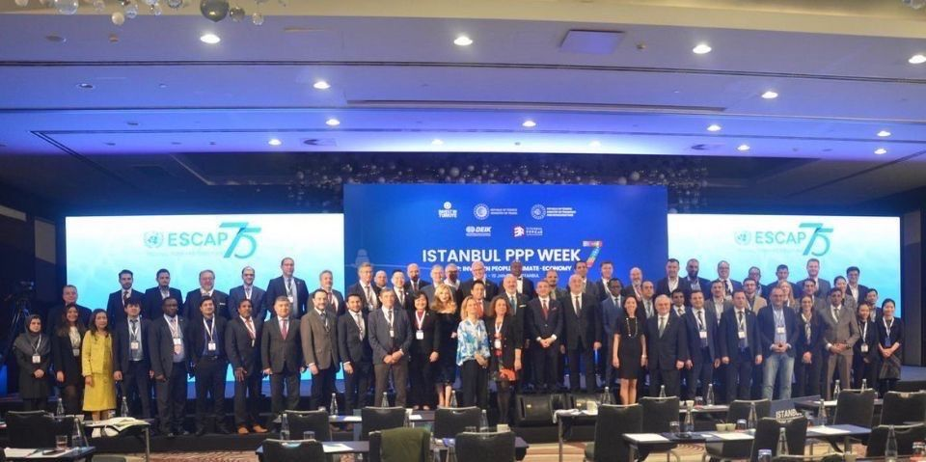

During the 4 days of the event over 150 PPP practitioners - many from emerging economies - participated in a forum of practitioners who shared ideas, best practices and latest tends in 30 sessions. (experts in the field of PPPs) discussed ways to implement PPPs as a tool for development and the achievement of sustainable development goals [SDGs,](https://www.linkedin.com/feed/hashtag/?keywords=sdgs&highlightedUpdateUrns=urn%3Ali%3Aactivity%3A7023020867471183872) LTIIA’s executive director took part in several of these sessions as a speaker/panelist, along with other PPP experts from various backgrounds and jurisdictions, eliciting a lot of interaction.

 

* **ASEAN Sustainable Leadership in Infra Program (ASLIP)–**a UK Treasury/ *Infrastructure and Projects Authority* initiative targeting Governments across the ASEAN region looking to drive economic recovery through the mobilisation of private capital and expertise to deliver, finance and manage sustainable infrastructure: LTIIA’s executive director presented LTIIA & hosted the Sustainable PPPs webinar (27 Jan). A key objective of the course is to expose ASEAN member states to institutions and actors such as LTIIA.
* **Presentation LTIIA to HEC business school Alumni (Paris-14Feb**);

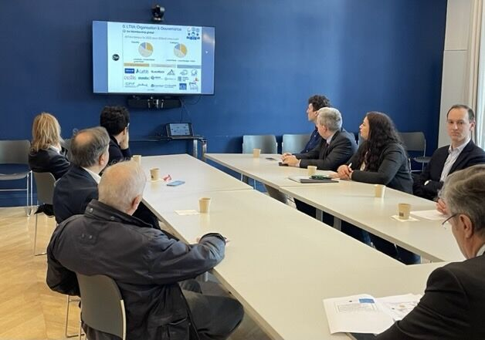

* **Berlin- PEI GLobal Infrastructure summit (20-23 March)**

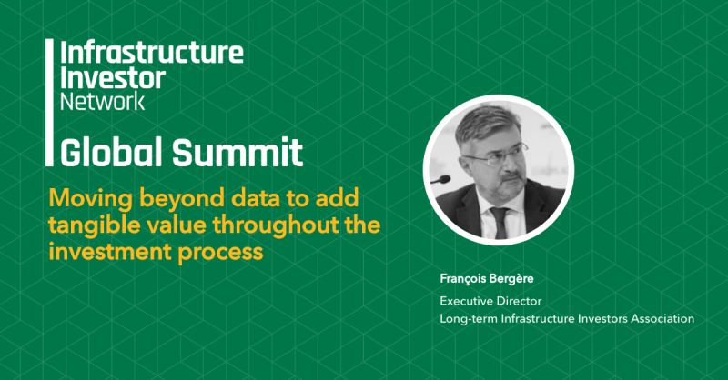

LTIIA Exec.Director F.Bergere debated the value of [ESG](https://www.linkedin.com/feed/hashtag/?keywords=esg&highlightedUpdateUrns=urn%3Ali%3Aactivity%3A7044212255026012160) data for [sustainability](https://www.linkedin.com/feed/hashtag/?keywords=sustainability&highlightedUpdateUrns=urn%3Ali%3Aactivity%3A7044212255026012160) in Infrastructure at Berlin Global Summit and engaged with multiple infrastructure actors.

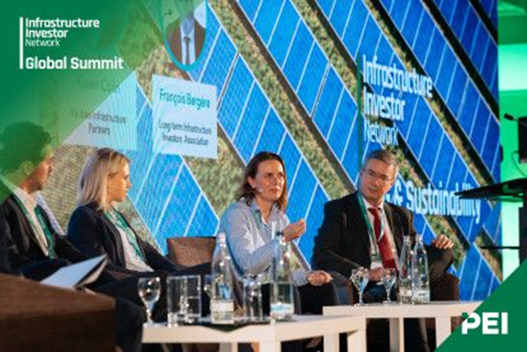

* **Future-proof Infrastructure congress by GIB (28 March)**

LTIIA took part along with D20-LTIC and WAPPP to a debate on PPP and blended finance

* **Joint LTIIA & D20-LTIC webinar on FAST-Infra with GIB for our members on May 30th**

LTIIA also participated in:

* **Finance in Common Exec Com. Mtgs,**
* **preparation working groups for the New Global Financing Pact Summit (to be held on June 22-23rd),**
* **as well as meetings organized at OECD on the FAST-Infra and Blue Dot Network (BDN) initiatives for sustainable infrastructure.**

**Organized events**:

* LTIIA event at LBP AM with AMF (Paris-6 Feb)

Paris-based members of LTIIA met at LBP AM headquarters to hear from AMF (French Financial authority) about [SFDR](https://www.linkedin.com/feed/hashtag/?keywords=sfdr&highlightedUpdateUrns=urn%3Ali%3Aactivity%3A7027281156869914624) regulation (Art 8 & 9) and implications for [infrastructure](https://www.linkedin.com/feed/hashtag/?keywords=infrastructure&highlightedUpdateUrns=urn%3Ali%3Aactivity%3A7027281156869914624) investors. Thanks to [Bérénice Arbona](https://www.linkedin.com/in/ACoAAAIJDJIBEK43pwUjmRJHVF1-Oxiw0Zz91Rs) and her team at LBP AM for hosting the event

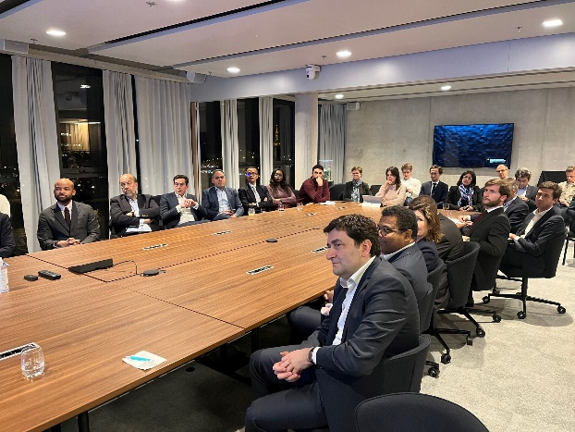

* Members are invited to make proposals as to possible locations and themes for the next events
* LTIIA Board meeting took place on Mar 1st by videoconference focusing on our work program for 2023

* F.Bergere took part for LTIIA in the PPP Forum organized by Public development Bank CDG Invest in Rabat, Morocco on May 9th .

Where he shared lessons learned from investors on how to accelerate the mobilization of private sector investments in infrastructure.

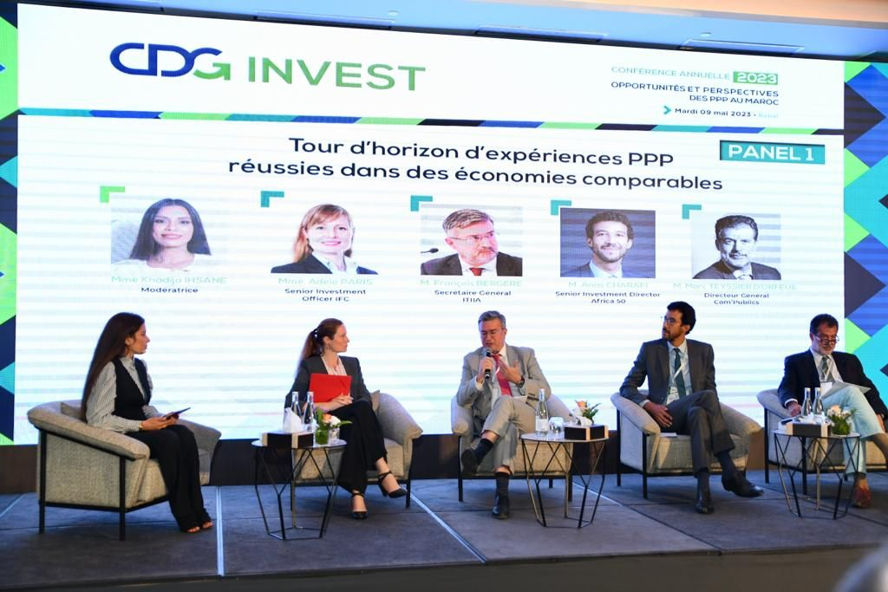

* Launch of Biodiversity Working group (Paris-23 May)

The launch of the Biodiversity Impacts Analysis for Real Assets (BIARA) working group hosted by Rivage Investment at the Salon de l’Hotel des Arts et Métiers, in Paris, on May 23rd 2023. This working group hosted by the Long Term Infrastructure Investor Association and coordinated by Carbone 4 seeks to bring together representatives from the financial sector, academics, and infrastructure project developers to develop robust methodologies to assess biodiversity impacts of infrastructure assets

* **FAST-Infra Initiative**



**FAST**-**Infra** (“*Finance to Accelerate the Sustainable Transition-Infrastructure*”) is a market place, industry-led initiative by CPI, HSBC, IFC, GIF and Macquarie, to scale up the financing of sustainable infrastructure in emerging markets, through 3 complementary dimensions:

- a sustainable infrastructure labelling system (**FAST**-**Infra sustainable Infra Label**), together with its data repository. LTIIA supported this initiative early on, and submitted its candidacy- which was endorsed- to be part of the FAST-Infra label Executive advisory committee.

* A multi-stakeholder collaborative digital platform ( **FAST**-**Infra platform)**

[**https://www.fastinfraplatform.com/**](https://www.fastinfraplatform.com/)

* In due time, targeted market interventions to promote innovative financing solutions & scale up investment in Sustainable Transition Infrastructure

<https://www.climatepolicyinitiative.org/fast-infra/>

<https://www.oneplanetsummit.fr/les-coalitions-82/fast-infra-229>

A permanent multistakeholder non-profit association, FAST-Infra Group (FIG) was established in France in August 2022; the Association brings together state and public, private industrial and financial, multilateral, and civil society institutions committed to deploying sustainable infrastructure globally. Our founder and honorary chair T.Deau has been designated to be the first Chair of FIG. LTIIA Executive Director F.Bergere has been approached in March by the Fast-Infra sponsors to step in as temporary CEO for the holding company while a new, permanent CEO is being sought. This was endorsed by LTIIA Board, subject to revision by summer of 2023.

* **Publications:**
* 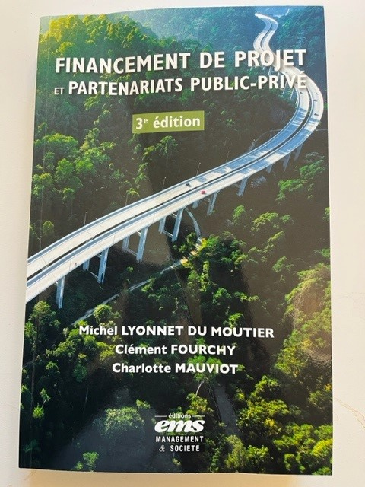 A new edition of the ***Project Finance & PPPs*** handbook in French, with a foreword from F.Bergere (LTIIA) was published in January 2023: an updated and enriched version with a new chapter devoted to financial investors in infrastructure, their constraints and operating methods. A reference tool to put in all hands, public and private, at a time when the challenges related to the financing of sustainable development and energy transition are more important than ever!
* **Membership:**

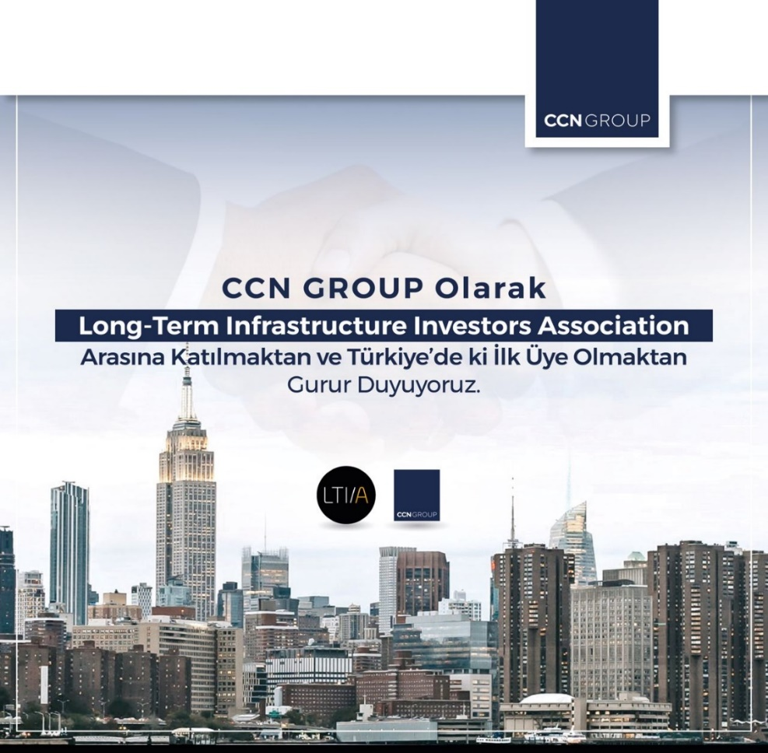

We are happy to welcome our new member CCN - the first from an emerging market (Turkey).The Turkish group CCN covers many dimensions, being both a developer, a construction contractor (EPC), an asset owner/equity investor and an asset manager ; they bring an interesting angle to our association and a new profile that should mark a diversification of our footprint towards emerging markets.

<https://www.ccngroup.com.tr/en/>

* **Miscellaneous:**

Media:

-A special report by Les Echos, France’s leading economic & financial daily, on Thierry Deau, founder and CEO of Meridiam , founder and Honorary chair of LTIIA,

<https://www.lesechos.fr/weekend/business-story/thierry-deau-le-patron-tres-engage-du-fonds-meridiam-1900047?xtor=CS4-6235>

- InfraVia launches a Critical Metals Fund with the backing of the State: <https://infraviacapital.com/infravia-launches-a-critical-metals-fund/>



