# 

**Spring-Summer 2024 Newsletter:  
*A new perspective for LTIIA as it turns 10***

After significantly dropping in 2023 as deals were limited by high interest rates and inflation, fundraising in infrastructure and the number of funds closing remained low in the first half of the year. 2024 is on track to remain a challenging year for the Global economy with political instability in many western democracies adding to the long list of external geo-political and natural shocks weathered over the last few years.

Infrastructure, though credited with being more resilient to cyclical variations, is not immune. And yet, more than ever, investors and fund managers are key to a sustainable recovery and development of our economies and societies. Simultaneously, we see a trend towards greater specialization strategies, with energy transition and digital infrastructure leading the way and providing a tailwind to new sub-sectors, creating opportunities for managers and investors alike ( as explored in our upcoming *report on Infratech*-see below).We are also seeing the emergence of new concerns such as increasing the resilience to cater for Climate-change adaptation.

Against this moving backdrop, LTIIA has engaged in a critical review of achievements assessed against its initial objective: to promote infrastructure as an asset class through the development of analytical tools and performance benchmarks, as well as through the sharing of best practices among the investment community. The roadmap adopted in 2019 called for:

-Expand & Diversify membership base, with a Focus on Limited Partners, and better geographic balance

-Develop a Community of Practice in Infra Finance by combining cooperation with academia and in-house expertise

-Provide guidance, contribute to promote standards & disseminate Knowledge products as Public goods

Despite recognized strengths and significant achievements, LTIIA’s management has come to the conclusion that it is not yet in a position to operate as a fully legitimate voice for the global industry, due to size and resources constraints. It has identified an opportunity to scale up, through a new approach, leveraging a recognized investors association.

Accordingly, the proposed move is to bring LTIIA closer to a leading association of investors, as its new Infrastructure chapter. Invest Europe (<https://www.investeurope.eu/> ), the selected, Brussels- based, organization, is the world’s largest association of private capital providers.It represents Europe’s private equity, venture capital and increasingly infrastructure investment firms, with the setting up earlier this year of a dedicated infrastructure Roundtable convening 34 investors LPs and GPs**.**

Invest Europe is interested in getting closer to LTIIA to accelerate its ramp-up in Infrastructure, and there is a clear complementarity and limited membership overlap between the 2 structures, as well as a shared purpose to facilitate and promote investment.

The envisioned convergence would eventually lead LTIIA, after a transition period, to integration within Invest Europe: membership would be open to any current member with interest or business in Europe, full membership being reserved for those having a permanent establishment, but other forms of participation being offered for our non-European based members.

The matter will be discussed and put to the vote at the upcoming General Meeting to be scheduled at end-September

**Vincent Levita Francois Bergere**

*Chair Executive Director*

**Other developments:**

Otherwise, and as part of its activity program for 2024, LTIIA has embarked on the following working themes:

- **Infratech: the new frontier of Infrastructure investment**

How can/do investors manage corresponding risks & bring concrete improvements in energy transition, energy efficiency, energy security?

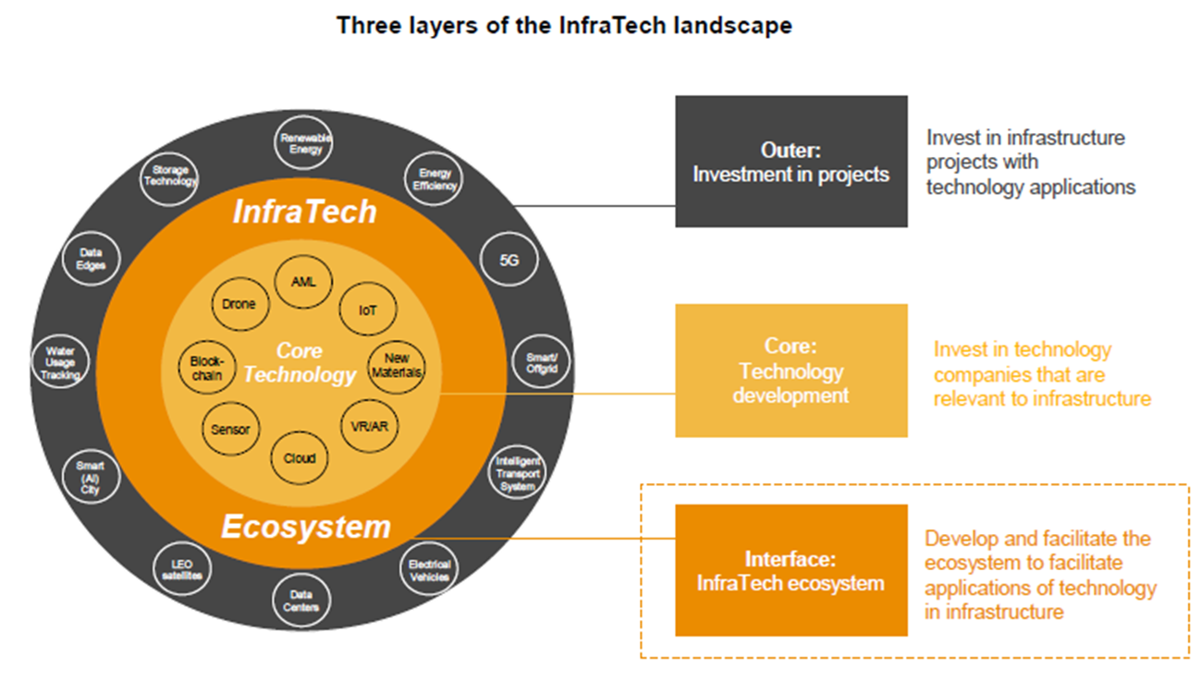

The corresponding working group set up by LTIIA, comprising over 15 members’ representatives, held its last session in June after half a dozen such meetings. That allowed us to identify new trends and fascinating case studies contributed by our members as well as other interested research-focused industry bodies, highlighting and showcasing those trends and their impact. The report is expected to be published and disseminated by fall 2024.



Following up on the 2022 report jointly commissioned by LTIIA and EDHEC Infra on Infrastructure resilience to external shocks, a timely study disseminated and presented to hundreds of investors & managers globally, another LTIIA -commissioned report was issued by EDHEC Infra in Spring 2024, around <https://www.ltiia.org/wp-content/uploads/2024/05/2024_EDHEC-LTIIA-smart_infra-diversification-report.pdf> .This study, backed by robust data, deals with how investors can achieve diversification within their infrastructure allocation and show the merits of adding unlisted/ illiquid infrastructure equity and debt to a multi-asset class portfolio. The paper covers Diversification of the infrastructure portfolio itself and implications for portfolio construction and deal selection, as well as Diversification of the total portfolio with infrastructure investments.



Among the many takeaways highlighted during the joint LTIIA-EDHEC Infra webinar on April 25th: the demonstration that it is possible to build portfolio with fewer assets & achieve higher risk-adjusted returns, thus accommodating constraints faced by many private infra investors.

**EU Commission:**

A recognition of it role in representing the industry at the European level, LTIIA was invite to take part in the DG Clima Consultative commission on Climate resilience financing, with a first meeting taking place under the aegis of commissioner W. Hoepstra at the Commission’s Headquarters in Brussels on May 14th. Further meetings are planned from September onwards with a report to be issued by end-2025, in time for the new multiannual financial framework adoption.

## LTIIA participation in Industry events:

Among the events which LTIIA took part in over the last months were :

* **8th Istanbul PPP week (5-7 Mar 24)**

During the event over 100 PPP practitioners - many from emerging economies - participated in a forum of practitioners who shared ideas, best practices and latest trends , and ways to implement PPPs as a tool for development and the achievement of sustainable development goals [SDGs,](https://www.linkedin.com/feed/hashtag/?keywords=sdgs&highlightedUpdateUrns=urn%3Ali%3Aactivity%3A7023020867471183872) LTIIA’s executive director took part in several of these sessions as a speaker/panelist, along with other PPP experts from various backgrounds and jurisdictions, eliciting a lot of interaction.

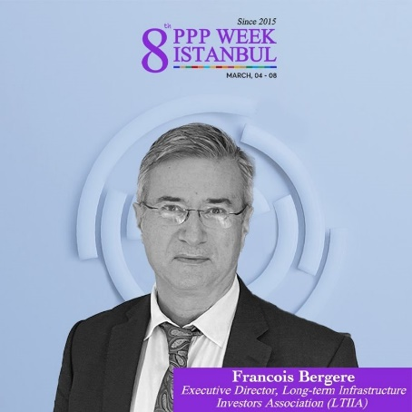

**-Berlin Global Infra summit (Mar 18-21)-with LTIIA manning a joint stand with Fast-Infra**

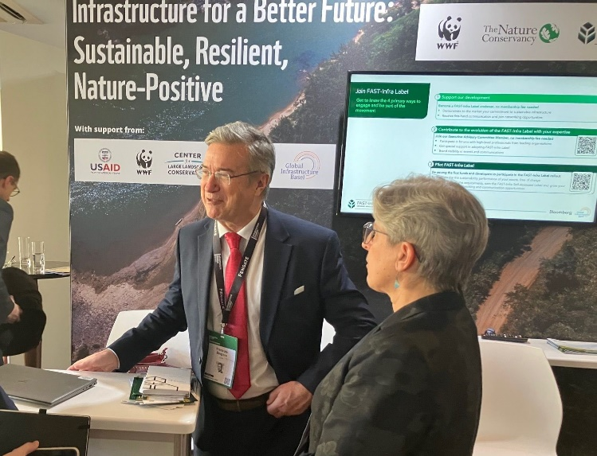

**-Paris: OECD Infra Forum - Apr 9-10**

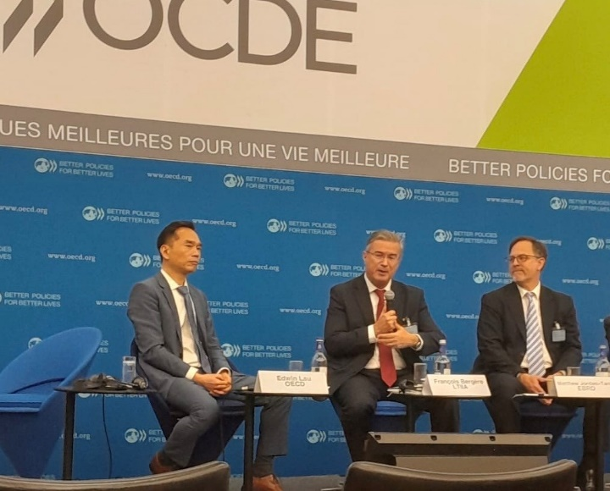

Discussion centered on the role of global sustainable infrastructure standards such as FAST-Infra and BDN + presentation to the “Friends of Infrastructure” meeting of Ambassadors to OECD on June 12th ,

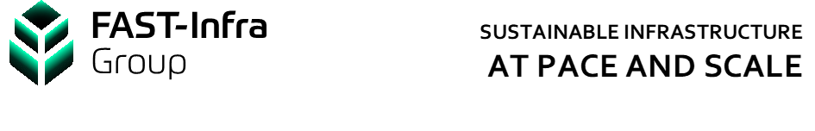

-**Paris**: SYNTEC Ingenierie- Presentation 10 Apr 2024

-**Brussels** : Meeting with EU commission- DG Clima 14 May

**-Paris**- Rencontres de la construction -12 Jun 2024

**Organized events**:

* LTIIA Board meetings took place by videoconference on:
* Feb 13th focusing on our work program for 2024
* June 27th, on the issue of joining Invest Europe
* An information webinar for LTIIA members about the envisioned convergence with Invest Europe will be jointly held by both structures’ management of Thu, July 18th
* The Annual General Meetings (both ordinary and\ extraordinary) are expected to be held in the 2nd half of September to discuss and vote on the perspective of joining Invest Europe.

* **Miscellaneous:**

**- InfraVia Capital Partner**

*May:* InfraVia acquires a majority stake by investing in GIGA Storage a leading player in Battery Energy Storage System development, construction, & operations in Benelux.

*June:* Heygaz Biomethane, a portfolio company of funds managed by InfraVia reached is to purchase the leading Irish biogas and biomethane producer, Ormonde Organics.

**Meridiam:**

*June:* Construction work started in Germany on the NeuConnect, the first UK- German energylink financed by both Meridiam and fellow LTIIA member AllianzGI.

*July:* has reached financial close on the Aragon Roads project in Spain, consisting of the upgrading, rehabilitation and maintenance for 25 years of an existing 183 km road. Construction will start at the end of 2024 and should be completed in the first half of 2027.

**-Allianz GI** :

The SDG Loan Fund1 successfully mobilized USD 1.1 bn of investor capital to advance the UN SDGs in emerging markets, using an innovative “blended finance” model. Also Investing in the fund along Allianz (the fund manager), is another LTIIA member: Skandia.

**Manulife Investment managt:**

*April:* Manulife led a $520 million in a capital raise for Nexamp, a leading independent renewable energy provider and US largest community solar developer and owner.

**Rivage:**

*February:* Rivage Investment announced an agreement on a €150 million debt financing of Econergy, a publicly-traded Independent Power Producer (IPP) that will support the delivery of an ambitious pipeline of European PV, wind, and storage projects

**Eurazeo:**

*January*  :ramps up its support to the deployment of electric mobility in Europe through its Eurazeo Transition Infrastructure Fund, by re-investing in Electra, a fast charging specialist. This part of a €304 million fundraising, will give the operator new means for its development. *************************